Go to localhost:8080

Click Manage Jenkins

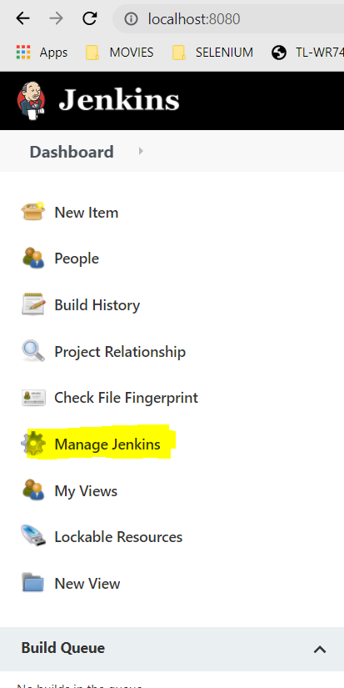

Click Configure System

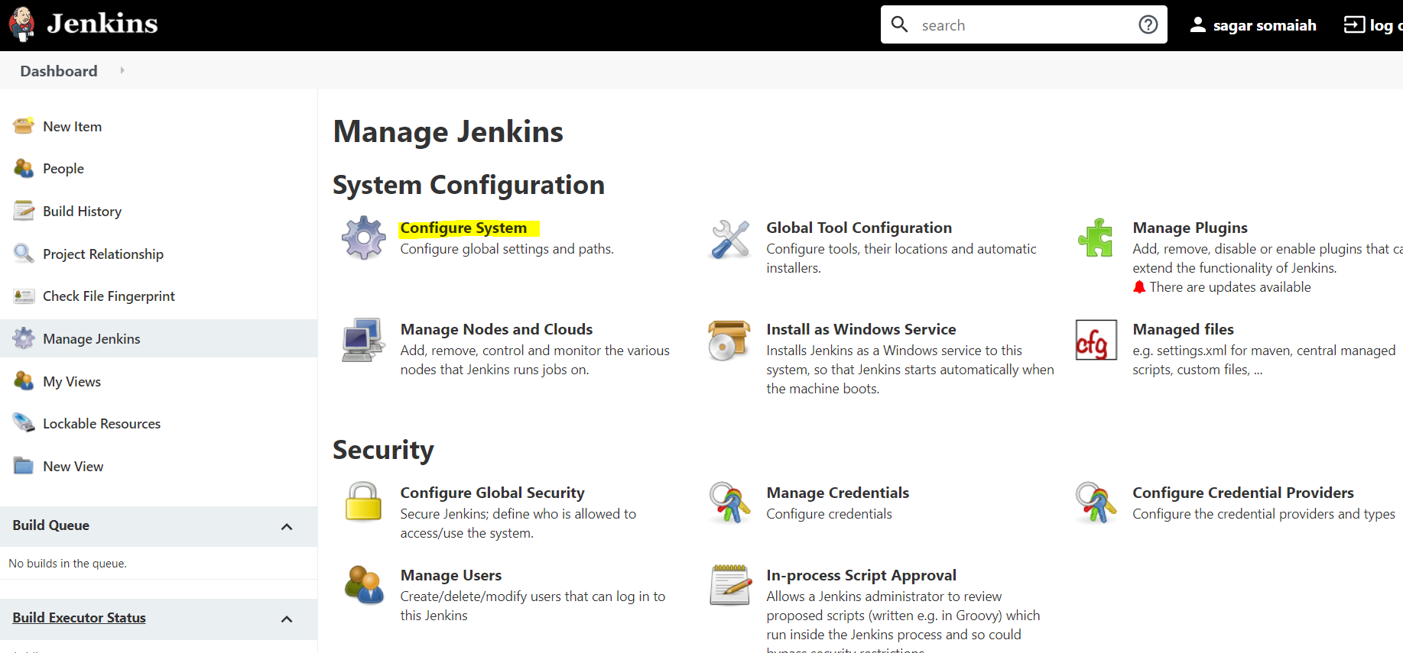

Scroll down until you see Email notification

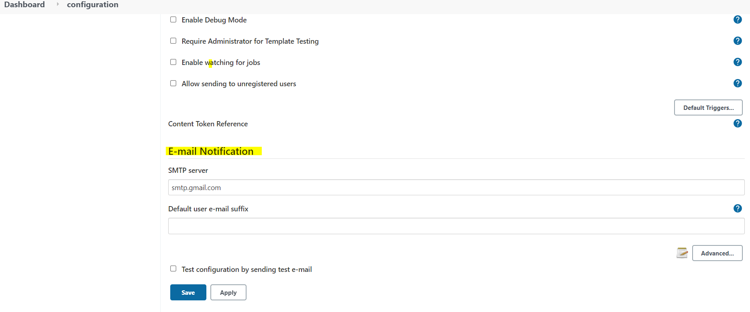

Click Advanced on left side and fill the email , password,smtp port(465 for gmail)

Smtp server- smtp.gmail.com

Check “Use SSL”, Apply & Save

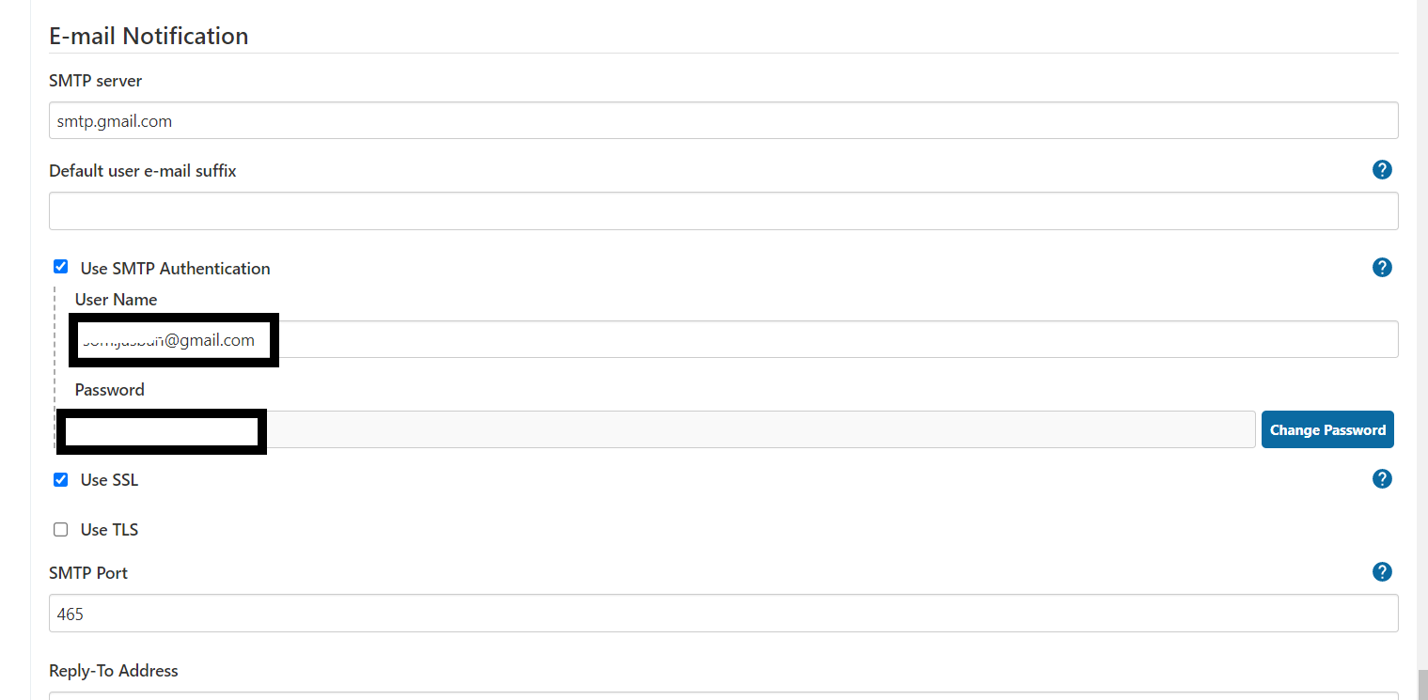

To Verify check Test Configuration by sending test email

Scroll up to Extended E mail Notification,

Fill in SMTP server – smtp.gmail.com, smtp port -465,

Apply and save

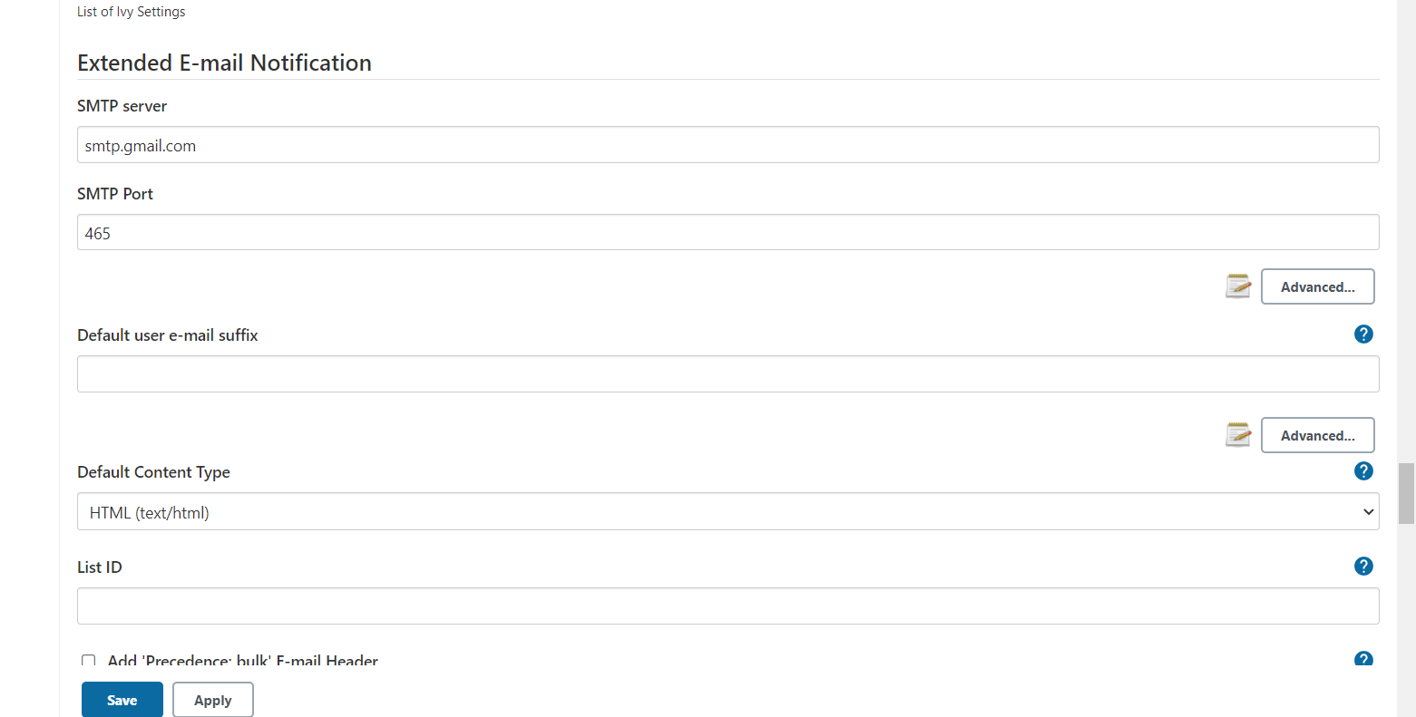

Click Default triggers (click advance under Extended email notification and choose always

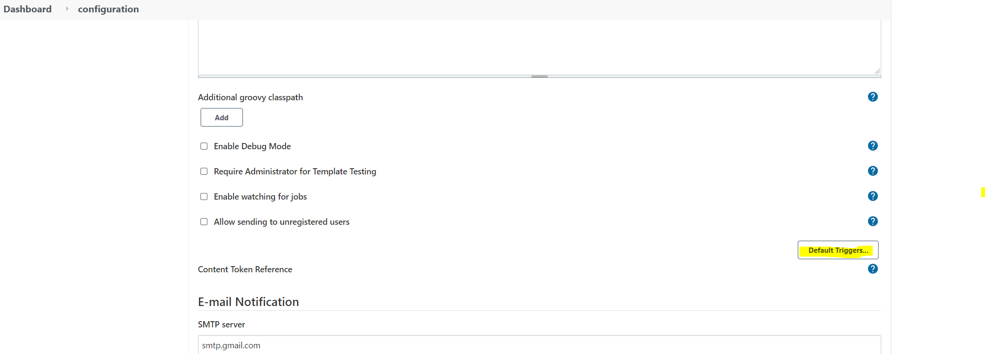

The Above will configure the mail

To add mail to project

Select the build and click configure

Click post build actions

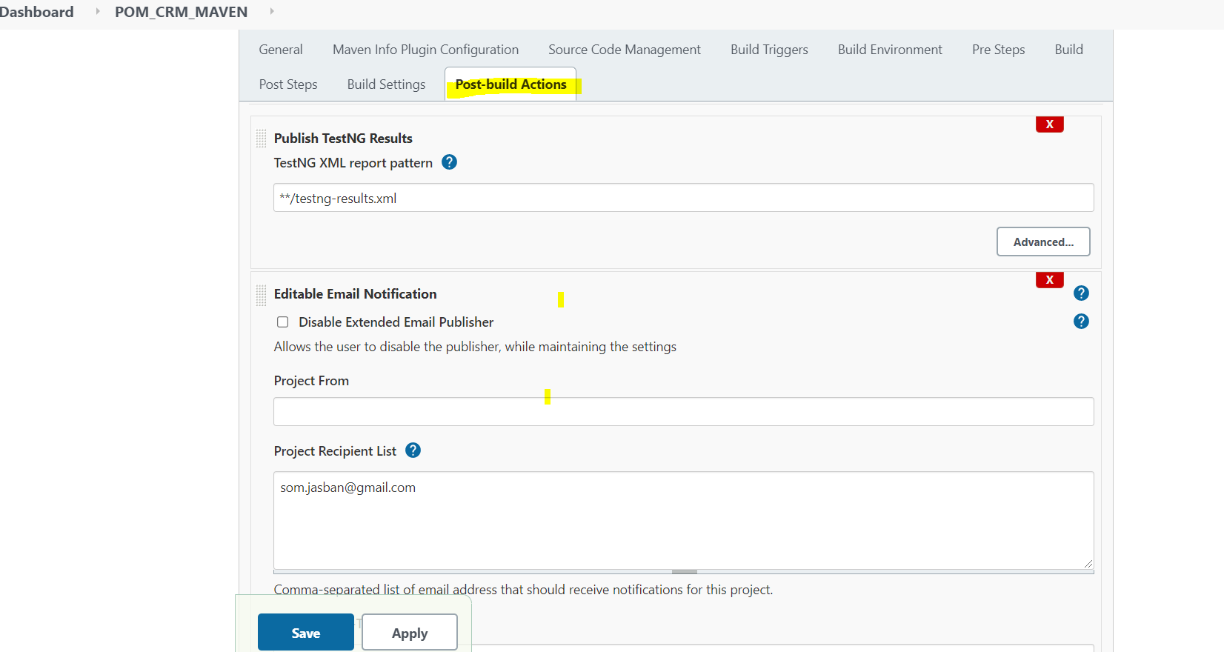

Add post build action and choose Editable Email Notifications

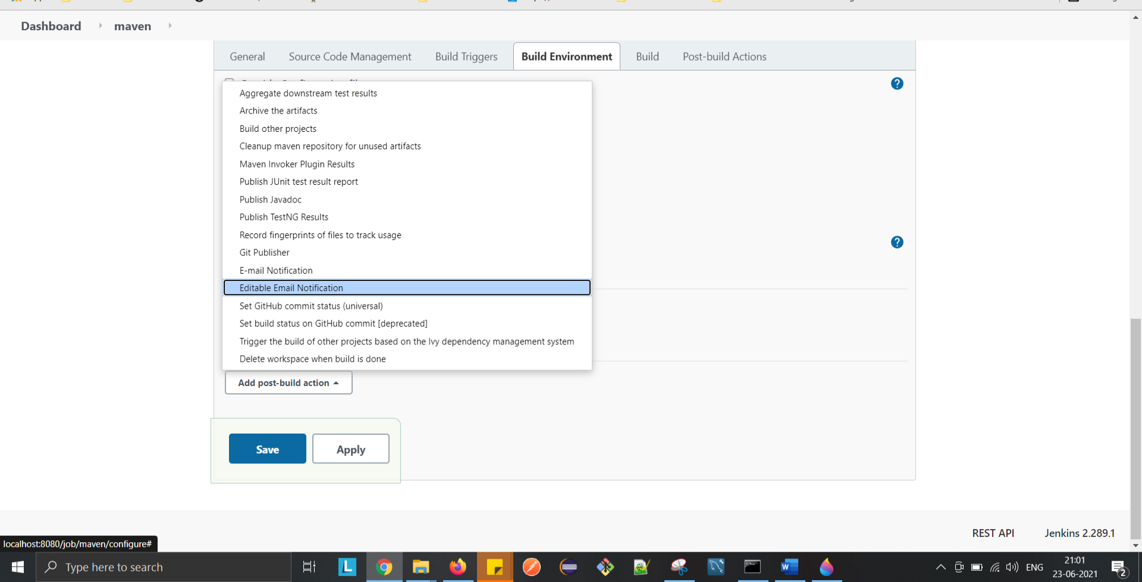

Enter to mail under Project Receipient list

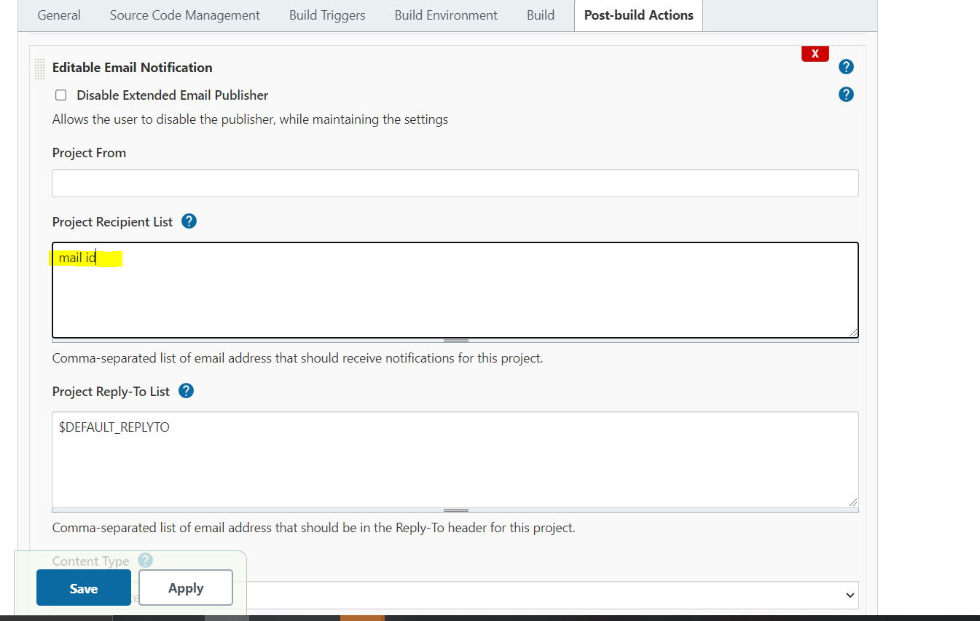

Click Save and apply